# GOVERNMENT OF KARNATAKA

158- GOVERNMENT POLYTECHNIC, NAGAMANGALA DEPARTMENT OF COLLEGIATE &TECHNICAL

# EDUCATION

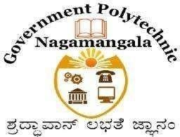

A Report on

## COURSE: - AI & ML (20CS51) INDUSTRIAL VISIT

“COMPUTER SCIENCE & ENGINEERING”

NAMES: MANU P SEMESTER: - 5TH REG .NO: - 158CS23302

Under the Guidance of

## Mr. DEVARAJU Sir

Lecturers Department of CSE

DEPARTMENT OF COMPUTER SCIENCE & ENGINEERING GOVERNMENT POLYTECHNIC

Nagamangala-571432

**REPORT ON INDUSTRIAL VISIT**

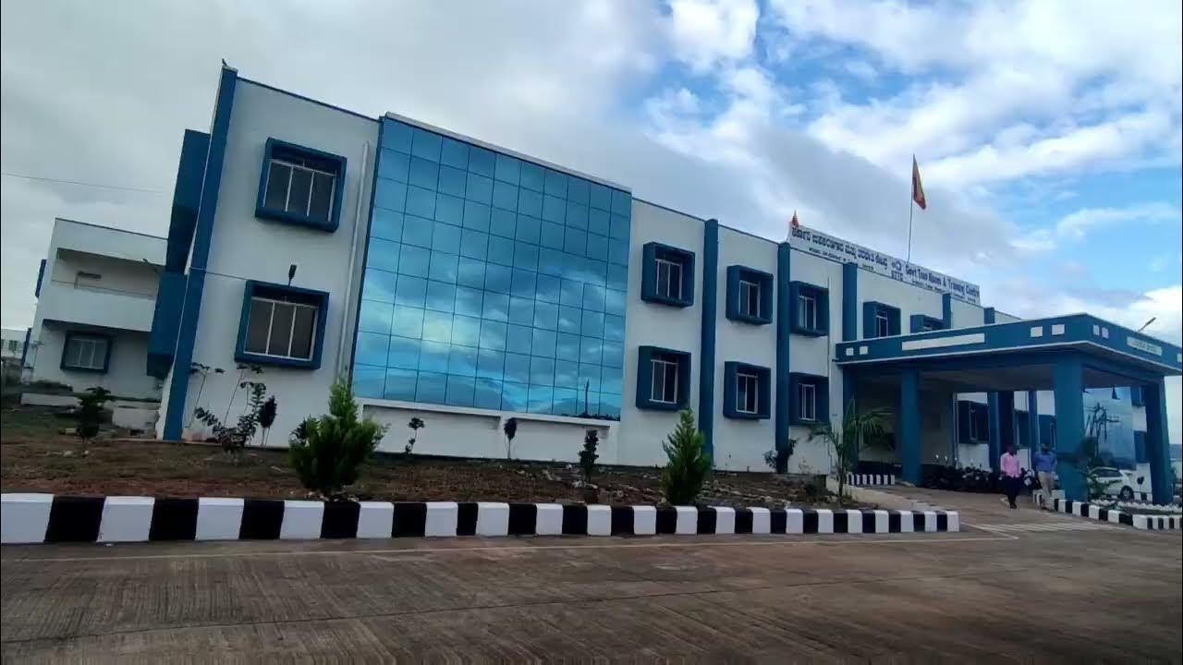

**Institution:** Government Polytechnic Nagamangala

**Department:** Computer Science and ENGG

**Date of Visit:** 25/10/2024

**Place of Visit:** Government Tool Room & Training Centre (GTTC), Magadi

### Introduction

The Government Tool Room & Training Centre (GTTC) in Magadi is a key institution for advancing technical skills in tool design, precision manufacturing, and industrial automation. Established to bridge the skills gap in the manufacturing sector, GTTC provides specialized training in cutting-edge technologies such as CNC machining, Programmable Logic Controllers (PLCs), and other automation systems that are essential for modern industry standards.

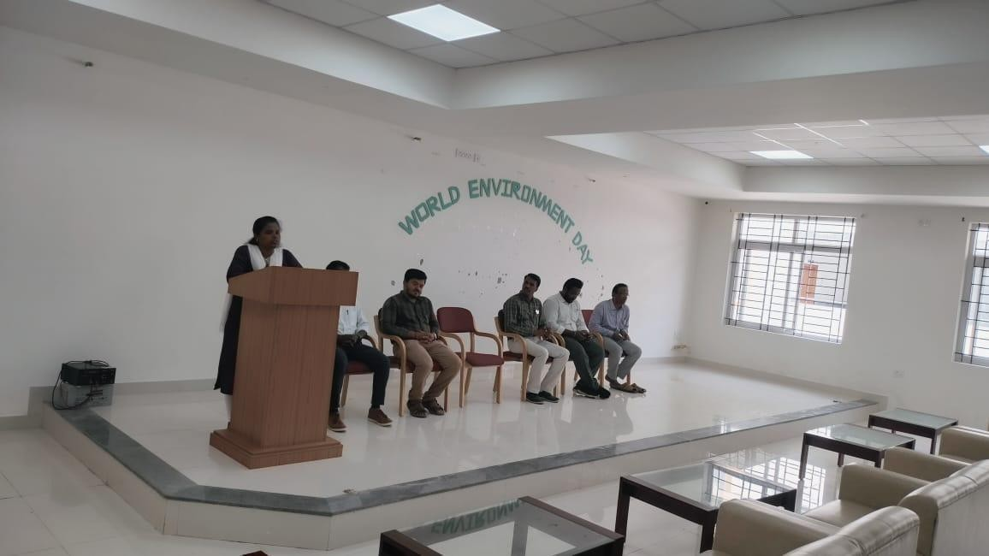

### Objective of the Visit

 To understand practical applications of AI, ML, and engineering concepts in industrial tools and training.

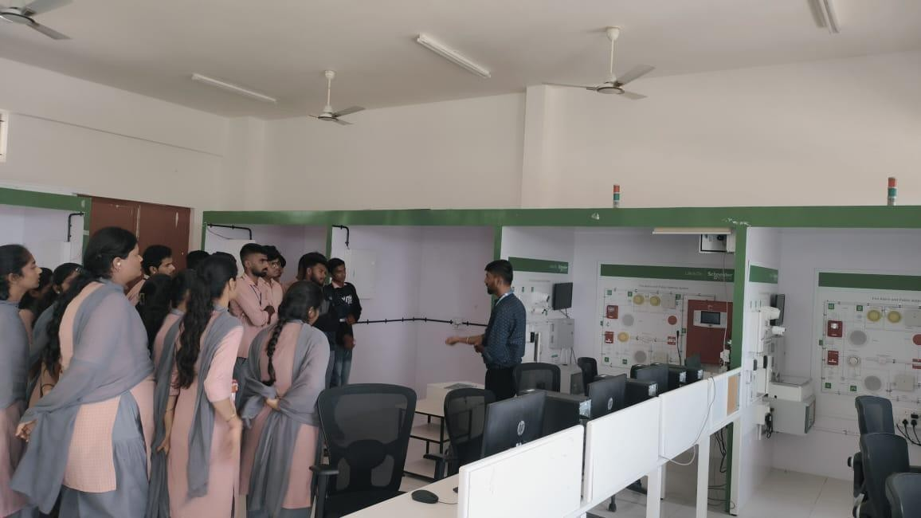To explore the manufacturing process, CNC machinery, and advanced training facilities

### Overview of GTTC Magadi

 GTTC Magadi is known for its contribution to technical education and precision manufacturing.

It offers advanced training on modern machines like CNCs, and practical skill development in tool and die-making, which is essential for industries

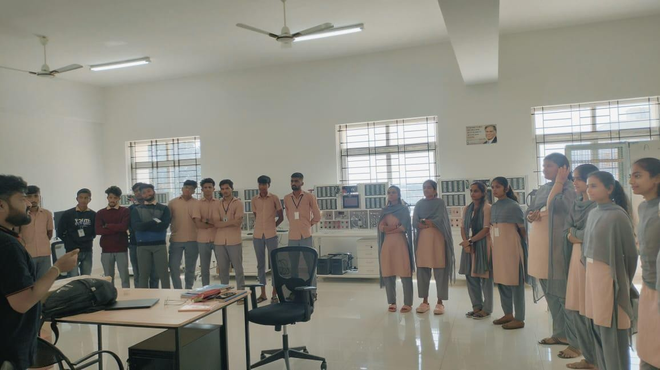

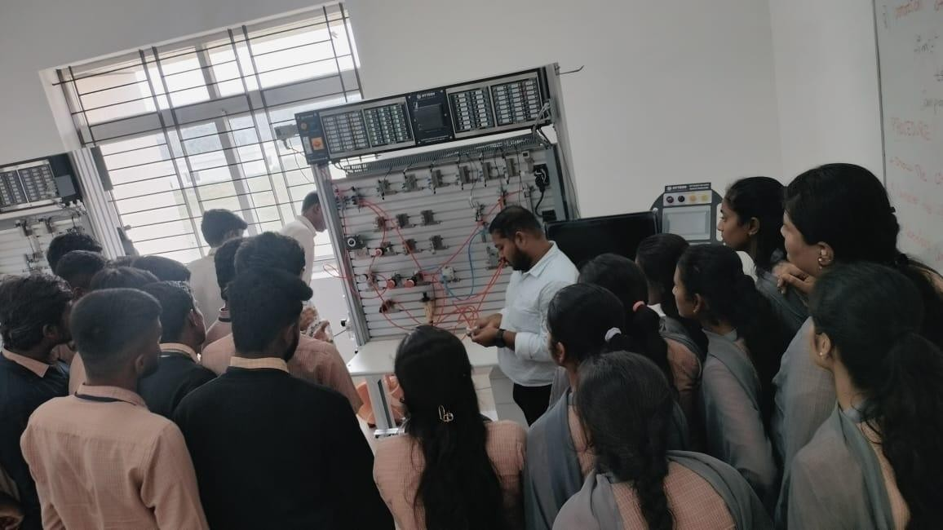

1. **Visit Details ** **Introduction Session:** We were given a brief overview of GTTC’s facilities, objectives, and areas of expertise.
   * **Workshop Tour:** o Observed various CNC machines, lathes, milling, and grinding machines.

o Demonstration of the production process, from design to finished products, showing how precision tools are made.

* + **Training Programs:** Information was shared on the diploma and certification programs GTTC offers in collaboration with industries, which help bridge the skill gap.
  + **Hands-On Exposure:** Students experienced hands-on training with CNC programming and tool setup, giving insight into machine learning’s role in manufacturing.

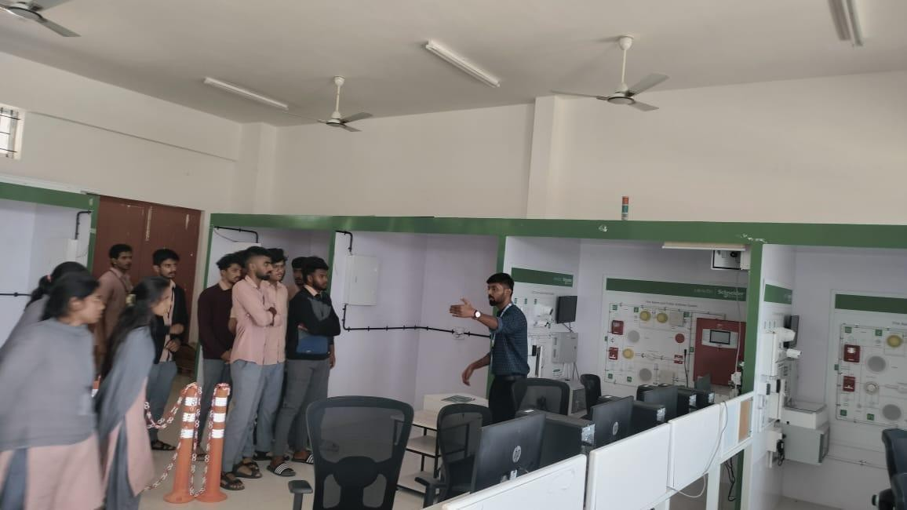

### Learning Outcomes

* + Understanding of how tools are designed, produced, and the role of automation.
  + Insight into CNC programming and its relevance to AI/ML in predictive maintenance.

Real-world exposure to the applications of AI and machine learning in modern manufacturing processes

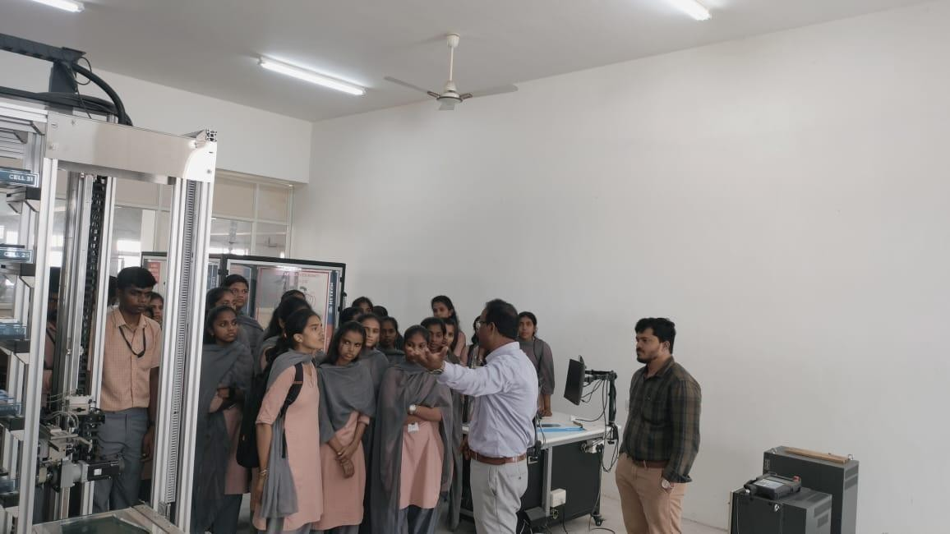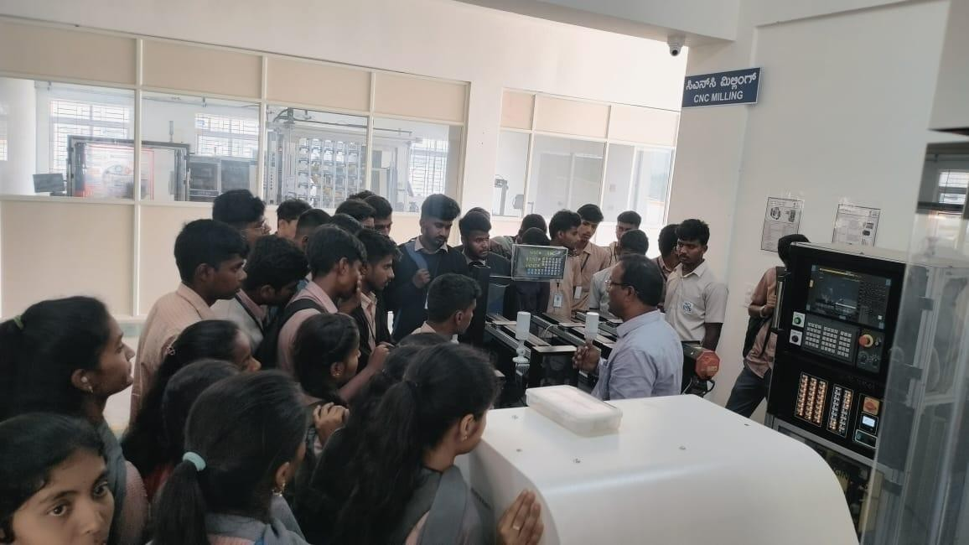

### Conclusion

* + The visit to GTTC Magadi provided valuable insight into the integration of technology in manufacturing.
  + It highlighted the importance of skilled training for careers in industrial technology, and how AI/ML can enhance precision in the industry.
  + This visit not only broadened our technical knowledge but also ignited our enthusiasm for exploring innovative solutions in the fields of engineering and technology.

The visit to GTTC Magadi was an insightful experience that highlighted several innovative technologies:

### Smart Stadium Technology

* + **Features:**
    - Integration of advanced sensor systems for real-time data collection.
    - IoT connectivity for seamless communication between devices.

### Applications:

* + - Enhances spectator experience through personalized services and information.
    - Improves crowd management and safety by monitoring attendance and behavior.

### Home Protection Systems

* + **Features:**
    - Smart sensors and devices for monitoring and automation.
    - Remote access and control through mobile applications.

### Applications:

* + - Increases residential safety by alerting homeowners to intrusions or emergencies. o Offers convenience through automation of lighting, security cameras, and alarms.

### Hydraulic Pressure Demonstration

 **Features:**

* Understanding of hydraulic systems and their components.
* Hands-on demonstration of how hydraulic pressure is generated and controlled.  **Applications:**
* Utilized in manufacturing equipment, construction machinery, and automotive systems. o Essential for processes requiring high force and precision.

### Renewable Energy Generation

 **Features:**

* Overview of technologies for wind, solar, and tidal energy.
* Explanation of energy conversion processes and efficiency measures.

 **Applications:**

* Provides sustainable electricity generation methods to reduce carbon footprints. o Promotes energy independence and supports eco- friendly practices.

